 |  | Esters |  |  |  |  | Amides
 | General Properties / Differences | More prone to hydrolysis, less stable in solution  Shorter DOA  Rapidly hydrolysed by plasma cholinesterases to para-aminobenzoic acid  PABA is associated with hypersensitivity reactions |  |  |  | 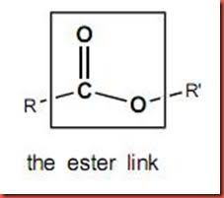 | Stable in solution, usually as a hydrochloride salt, therefore longer shelf-life  Longer DOA  Slower hepatic metabolism more prone to accumulation / toxicity  Hypersensitivity reactions are rare |  |  |  |  | 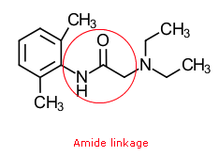
 |  | Cocaine | Benzocaine | Procaine | Chloroprocaine | Tetracaine | Lignocaine / Lidocaine |  | Prilocaine |  | Mepivacaine | Bupivacaine | Levobupivacaine |  | Ropivacaine
PC | Chemical  Structure | 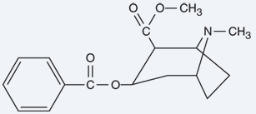 | 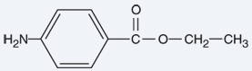 | 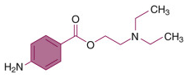 | 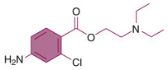 | 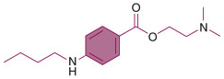 | 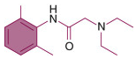 |  | 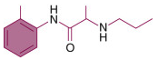 |  | 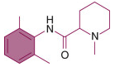 | 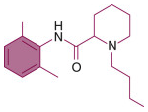 | 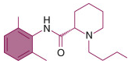 |  | 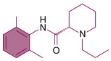
 | Trade names |  | Americaine / Cetacaine | Novocaine | Nesacaine | Pontocaine/ Amethocaine | Xylocaine |  | Citanest |  | Carbocaine, Isocaine | Marcaine | Chirocaine |  | Naropin
 | Isomerism  Rationale for use  Key notes of differentiation  Structure-activity relationships | Benzoic acid ester  Only naturally occurring LA used clinically  Used for ENT or cornea | Derived from para-aminobenzoic acid and ethanol  Marked hydrophobicity limited its use  Slow onset, short DOA | Structural template for modern anaesthetics  First injectable LA clinically  Was used for infiltration and spinal before lignocaine superseded its use | Onset and duration shorter than lignocaine  Used for epidurals in some regions  Causes thrombophlebitis | Mainly used topically  Due to really high lipid solubility | Achiral  Class 1b antiarrhythmic  IV administration decreases N2O requirements 10% and halothane requirements 28% |  | Racemic (S and R-enantiomers)  Amide derivative of toluidine. DOA 1.5 times lidocaine. Highest Cl of amide anaesthetics |  | Racemic (R+, S-)  Similar to lignocaine but useful in that it has a slightly longer DOA due to a tendency towards vasoconstriction > vasodilation  Methyl group on amine end | Racemic  Structural homologue of mepivacaine, butyl group on piperidine nitrogen  Prolonged sensory outlasting motor block: 35 times more lipid soluble, 3-4 times potency and DOA cf mepivacaine | Pure levorotatory S-enantiomer  Has a propyl chain rather than a butyl chain @ tertiary amine  50% less cardiac & CNS toxicity c bupivacaine. Useful plexus blocks where large doses req + long DOA |  | Pure levorotatory S-enantiomer  Propyl analogue of bupivacaine  S-ropivacaine is more potent + 25% less CVS toxic than R-ropivacaine  Differential block – epidurals as greater sensory block without significant motor block
 |  |  |  |  |  |  |  |  |  |  | Pipecoloxylidides
 | Formulations | 1-4% paste  1-10% solution | 1% | 1-2% | 1-3% | 0.5-10%  AnGel 4% | IV: 0.5/1/2%, Gel 2% & 4%  LMX-4 (age >2yrs)  Spray: 10%, Patch 5% (700mg)  Combined with oxymetazoline for ENT  Tumescent use for liposuction 35-55mg/kg |  | 0.5/1/2%  3% + felypressin  (V1 R ag, similar vasopressin but no antidiuretic effect) |  | 1.5% | 0.25 / 0.5%  +/- ad, +/- heavy (which is 80mg/ml of glucose) | 0.25 – 0.75% |  | 0.1/0.2/0.75/1%
 | Main contemporary uses | Topical use only for ENT | Topical use only  OTC cold sores solutions, lozenges, sprays | Epidural (rarely) | Epidural  Spinal  Peripheral blocks | Topical 4% gel (AnGel)  OTC products  Epidural / spinal (rarely) | Topical patches, Epidural 2%, Infiltration, blocks, airway topicalization  Infusion arrythmia 1-4mg/min  Infusion analg 1.5mg/kg bolus + 1mg/kg/hr |  | Was used classically for Bier’s block (40mls of 0.5%)  Spinals in Europe |  | Peripheral blocks mostly | Spinal up to 3mls heavy 0.5%  Epidural 15-30mls of 0.5% plain for surgical anaesthesia  Labour epidural 6-12ml bolus followed by 5 - 7.5ml/hr 0.25% | Epidural top-up10-20 mls 0.75%  Intrathecal 3mls of 0.5%  Labour analgesia 10-20mls of 0.25%, infusion 10-15mls of 0.0625%. Regional blocks |  | Regional infiltration/blocks 1-100mls 0.2%, catheters 5-10ml/hr of 0.2%  Labour epidural 0.1 – 0.2%  Top-up epidural 15-20mls 0.75%  Caudal block 1ml/kg of 0.2%
 | Relative Potency |  |  | 1 | 4 | 16 | 1 |  | 1 |  | 1 | 4 | 4 |  | 4
 | CC:CNS ratio |  |  |  | Lowest toxicity all agents |  | 7 |  |  |  | 4 | 3 | 5 |  | 5
 | Max dose (mg/kg) + adr | 3 mg/kg  1.5mg/kg topically |  | 15mg/kg | 10mg/kg |  | 3 or 4 (depending on source)  6 to 7 (depending on source) |  | 6  8 (with felypressin) |  | 5 | 2  2 | 2  2 |  | 3  3
 | Max total dose (mg) + adren |  |  |  |  | 100mg topical | 350  500 |  | 400  600 |  | 350  500 | 175  225 | 200  225 |  | 200  250
 | Toxic plasma dose (mcg/ml) | Reaches peak plasma in 30-40 mins from mucous membranes |  |  |  | AnGel (licensed >1mo), works 30 mins, lasts 6 hrs, store < 8 degrees, erythema & vasodilation. Do not apply > than 60 mins | 1 - 5 | Analgesia | >5 mcg/ml |  | >5 mcg/ml | >4.5 mcg/ml  Peak plasma levels are reached in 30-45 minutes |  |  | 4 mcg/ml
 |  |  |  |  |  |  | 5 - 10 | Excitatory phenomenon: perioral numbness, tinnitus, visions, twitching  ↓ BP, ↓ inotropy
 |  |  |  |  |  |  | 10-15 | Seizures, unconsciousness
 |  |  |  |  |  |  | 15-20 | Coma, apnoea
 |  |  |  |  |  |  | > 20 | CVS collapse, PEA arrest
PK  A | pKa | 8.7 | 3.5 | 8.9 | 9.1 | 8.5 | 7.9 |  | 7.8 |  | 7.6 | 8.1 | 8.1 |  | 8.1
 | % unionised pH 7.4 | 5% | 100% | 3 | 5 | 7 | 25 |  | 24 |  | 39 | 17 | 17 |  | 17
 | Lipid solubility |  |  | 0.6 |  | 80 *HIGH* useful topically | 2.9 |  | 0.9 (lower of amides) |  | 1 | 28 (highest of amides) |  |  | Lower than bupivacaine < motor block
 | Partition coefficient |  |  |  |  |  | 43 |  | 25 |  | 21 | 346 | 346 |  | 115
 | Protein binding % | 98 |  | 6% | NA | 76% | 70% |  | 55% |  | 78% | 96% | 98% |  | 94%
 | Protein binds to | Albumin and AAG | Albumin and AAG |  |  |  | Alpha-1 acid glycoprotein
 | Absorption site |  |  |  |  |  | IV > Intercostal > caudal > epidural > brachial plexus > femoral > sciatic > subcut |  |  |  |  | Biphasic epidural abs: 7 mins and 6 hrs |  |  | Biphasic epidural abs: 14 mins & 4 hrs
 | Vasoactivity | Potent intrinsic VC |  |  |  |  |  |  |  |  | Vasodilation is mild | Direct vasodilatory effect |  |  | Intrinsic VC effect low conc, not at high conc
 | Effect of adrenaline | N/A |  |  |  |  | Prolongs DOA by 50%  5mcg/ml adr = ↓ systemic absorption by 1/3 |  | Not necessary, has < VD vs lign + highly lipid soluble so fat takeup rapid |  | Can significantly prolong action | Less impact than lignocaine (as bupivacaine is more lipid soluble) |  |  | Adrenaline does not affect tissue uptake or DOA. High lipid solubility may be sequestration in tissues < peak plasma conc
 | Alkalinisation |  |  |  |  |  | 2mls of HCO3+ 8.4% to 20mls of LA
D | Distribution | Rapid breakdown in plasma with elimination half-life <1 minute |  |  |  |  | Typically two-compartment model: rapid & slow phases. Fast compartment eg Lung = highly perfused: major uptake site, attenuates arterial conc. Slow phase: muscle & gut: linear rate of decline
 | Vd (L/kg) | 0.9-3.3 |  |  |  |  | 1.3 (VDss) |  |  |  |  | 1 |  | 1
 | Vd (L) | 65 |  | 35 |  |  | 91 |  | 191 |  | 84 | 74 | 55 | 59
 | t1/2 alpha (mins) |  |  |  |  |  | 10 |  | 5 |  | 7 | 28 |  | 23
 | t½ B (mins) | 25-60 |  | 6 mins | 6 mins |  | 90-110 mins (1.6hrs) |  | 96 (1.6hrs) |  | 114 (1hr) | 210 (3.5hrs) | 156 (3.5hrs) | 108 (1.9 hrs)
 | Cross placenta M:F | Yes – NAS |  |  | Virtually none |  | 0.73 - ?Ion trapping in foetal acidosis |  |  |  |  | 0.32
M | Metabolism | Hepatic carboxylesterase  + plasma cholinesterases | Hydrolysis by plasma esterases that hydrolyse the ester bond  Benzocaine > ester hydrolysis > 4-aminobenzoic acid > acetylation acetylbenzocaine > ester hydrolysis to 4-acetaminobenzoic acid |  |  |  | N-dealkylation in liver. (Fastest of amides)  -> hydrolysis to monoethylglycine (MEG)  -> hydrolysed xylidide (MEGX)  -> hydroxylated to 4-hydroxy-2,6-xylidine  NB: Extrahepatic metabolism : lungs + kidney |  | Hepatic metabolism  -> hydrolysis to O-toluidine  -> hydrolysed to 4- and 6-hydroxytoludine |  |  | N-dealkylation primarily to pipecoloxylidide (less toxic) and pipe-colic acid |  | Aromatic hydroxylation in the liver via CYP1A2 and CYP3A4 to 3-hydroxy-ropivacaine & 4-hydroxy-ropivacaine, both have LA activity  Then 4-hydroxy-dealkylated ropivacaine
 | Rate |  |  |  | Particularly fast |  | Of the amides: Prilocaine (fastest) > Lidocaine > mepivacaine > bupivacaine > levobupivacaine (slowest)
 | Notable metabolites |  | Can cause MetHb |  |  |  | Principle metabolite is MEGX (monoethylglycinexylidide) = ↑ seizure risk |  |  | O-toluidine = MetHb  (↑ risk: sulfonamides, anaemia, Hb-opathy) |  |  |  | Active metabolites
E | CL (ml/kg/min) | 26-44 |  |  |  |  | 6.8-11.6
 | Cl (l/min) |  |  |  |  |  | 0.95 |  | 2.84 |  | 0.78 | 0.47 |  | 0.44
 | t1/2 elim (h)  t1/2B | 100 minutes |  |  |  |  | 1.6  Liver disease = >5 hours  Longer in CHF, elderly >2hrs and neonates |  | 1.5 |  | 1.9 | 3.5 |  | 4.2 (2 hours?)
 | Excretion |  |  |  |  |  | <10% excreted unchanged in urine  4-hydroxy-2,6-xylidine conjugate is main metabolite excreted in urine 80% |  | <5% excreted unchanged in the urine. Prilocaine metabolism in kidney |  |  | 5% excreted in urine as pipecolosylidide  6% excreted unchanged |  | 86% excreted in the urine, 1% unchanged, 37% 3-hydroxy-ropivacaine conjugated
 | Dialysable? |  |  |  |  |  | No
PD | Toxicity/ Cautions/ CIs | Hypertension, arrhythmia  Excess plasma conc = confusion, hallucination, seizures, cerebral haemorrhage, respiratory arrest, DIC, rhabdo, gut infarction | Methaemoglobinaemia has been reported in used as teething gel – no longer recommended |  | Thought to have lowest CNS and CVS toxicity of all agents in current use  Controversy around reports of adhesive arachnoiditis with accidental subarachnoid inj  Unique advantage for epidural infusion in neonates as rapidly cleared from plasma even in pre-term neonates | Suggested to cause neurotoxicity at high doses in animal studies resulting in cauda equina syndrome with repeated spinal dosing | Not recommended: paracervical or pudendal nerve block due to methaemoglobinaemia in neonate (due to a lack of methaemaglobin reductase in neonatal erythrocytes). Toxicity ↑ by accumulation of principle metabolite MEGX  TNS with lidocaine used spinally, in as many as 30% . Implicated in cauda equina syndrome LMX-4 proprietary liposomal formulation. Effective within 30 mins, only approved for >2yrs ago, doesn’t require refridgeration  Laryngotracheal spray of lidocaine – similar plasma lidocaine conc as an IV injection |  | Least systemic toxicity of all amide local anaesthetics (and less than lidocaine) but methaemaglobinaemia (>500mg dose) which limits its use  Not used for modern Bier’s blocks – reports of refractory cardiac depression leading to death in literature |  | Not favoured for epidural anaestheisa as mepivacaine is slowly metabolised by the foetus | LAST with bup = high mortality & morbidity as ↑ affinity for Na+ channels & ↑ lipid solubility  Adrenaline solutions contain Na metabisulfite -> preservative that creates acidic pH ~4 prevents oxidative decomposition  Not for Bier’s blocks: due to CC:CNS ratio  Risk of chondrotoxicity intra-articular LA (ropivacaine has lower risk of this)  Liposomal bupivacaine (low quality evidence, lack of benefit over bupivacaine) DOA 96hrs | Precipitates if diluted in alkaline solutions | Developed to have ↓ cardiotoxicity than bupivacaine, ↑ doses than racemic bup before signs of toxicity, but not conclusively when tested in [equipotent]  Precipitates if added to alkaline solutions. Ropivacaine solubility is limited at pH values above 6  Co-administration with ketoconazole (inhibitor of CYP3A4) has been shown to cause marginal 15% decrease in ropivacaine clearance in healthy pts  Chemically and physically compatible with fentanyl, morphine and clonidine
 | Elderly & Neonates | More sensitive
 | Pregnancy | Ion trapping -> placenta
 | Failure states |  |  |  |  |  | Respiratory – depress vent response to arterial hypoxaemia, so hypoxic drive pts at risk of ventilatory failure |  |  |  |  | Systemic bupivacaine following brachial plexus block stimulates ventilatory response to CO2

*references Stoelting, Petkov, Hugh & Hemmings, Oxford handbook of drugs in anaesthesia and intensive care, MAK95 and Millers, NPS MedicineWise Product Information
https://www.bjaed.org/article/S2058-5349(19)30152-0/fulltext#relatedArticles

Acidity prolongs the shelf life of adrenaline – so adrenaline containing LAs are more acidic

OTHER LAs to be vaguely aware of
- Etidocaine = Duranest
  - Amide LA with long DOA, increased bleeding during dental surgery
- Septocaine = Articaine + adrenaline for dentistry

Dibucaine
Dibucaine is a quinoline derivative with an amide bond in the connecting hydrocarbon chain. This local anesthetic is metabolized in the liver and is the most slowly eliminated of all the amide derivatives. Interestingly, dibucaine inhibits pseudocholinesterase and is used to differentiate individuals who have substitution mutations of the plasma cholinesterase enzyme.[³⁴] The dibucaine number is the percentage of plasma cholinesterase enzyme inhibited by dibucaine. A normal enzyme will be 80% inhibited by dibucaine, whereas an abnormal enzyme will be 20% inhibited.[³⁵]

MOA in a graph!
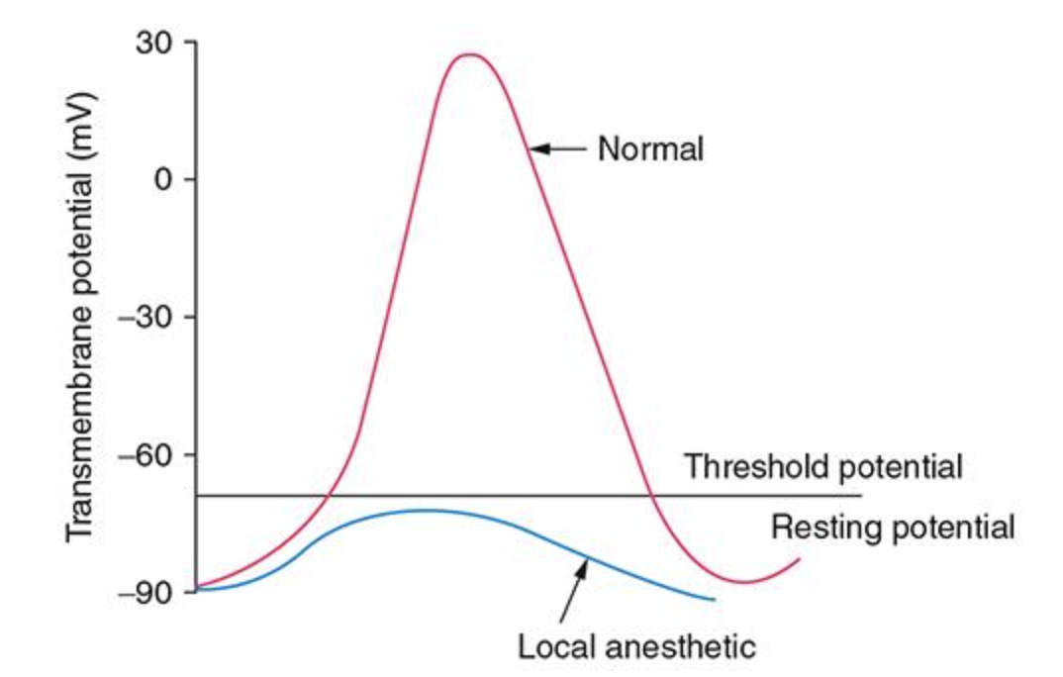

“Toxicity” – variations on a theme – don’t narrow just to LAST
CNS, CVS
Neurotoxicity
Total spinal
Methaemoglobinaemia
Nerve toxicity
Allergy, true allergy rare, but excipient allergy possible
Specific block “toxicity” – intercostal blocks – respiratory depression reduced accessory muscle strength, interscalene blocks Horner’s syndrome
Intrathecal – block height related SEs

