Agent | MAC (v/v%) | BGPC  @ 37°C | Oil:Gas PC | SVP @ 20°C (mmHg) | Boiling point (°C) | Notes:
Sevoflurane | 1.9% | 0.65 | 47 | 157 | 58.6 | M: 2-5% metabolised by CYP 2E1 to inorganic fluroride  Relative CI: Duchenne muscular dystrophy – vulnerable to hyperkalameia  Packaged in lightweight virtually unbreakable recyclable aluminium containers with a plastic liner, and has a small amount of water – to prevent degradation to hydrogen fluroride & silica tetrafluroride – highly acidic volatile compounds. Soda lime = Compound A (PIFE) and Compound B (PMFE). Time constants (brain 3.5m, VRG 5.6m, muscle 140m, fat 2600m)  GWP100 CO2 equivalent = 1.08 kg CO2 (for 1 MAC-hour at 0.5L.min FGF)
Desflurane | 6% | 0.42 | 19 | 669 | 22.8 | Sympathomimetic. Coughing / respiratory irritation at >1.0 MAC. More vasodilatory properties than sevo at an equivalent dose. Heated to 39oC in TEC6 with SVP of 1500mmHg  M: 0.02% metabolised by CYP 2E1 to inorganic fluroride. CO produced with dry absorbent  GWP100 CO2 equivalent = 22.42 kg CO2 (for 1 MAC-hour at 0.5L/min FGF)
Nitrous oxide  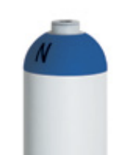 | 105% | 0.47 | 1.4 | 38,770 | -88.5 | NMDA R antagonist, GABAA, KOP R, ↓ CPSP  Critical temp (36.5), critical pressure 72 bar. M: not metabolised  Oxidises vit B12 (unable to function as a cofactor for methionine synthase, causing elevated homocysteine levels and reduced methionine – which is necessary for myelin proteins -> demyelination).  Acute B12 def = parasthesia, myelopathy and precipitate subacute combined degeneration of the cord, agranulocytosis, bone marrow suppression, psychosis  CI in PTX or recent ocular surgery (4-6 wks) – gas expansion. ETT cuff can distend – pressure should be checked, esp paeds  ENIGMA-II = does not ↑ death/ CVS complications. NAP 5: ↓ incidence awareness GA LSCS
Isoflurane | 1.2 | 1.4 | 98 | 240 | 48.5 | Causes respiratory irritation about half as much as desflurane  M: 0.2 metabolised by CYP 2E1 to trifluoracetic acid, inorganic fluoride  CO produced with dry absorbent  Only volatile agent with chloride ions
Enflurane | 1.7 | 1.9 | 97 | 172 | 56.5 | M: 2.4% by CRP 2E1 to inorganic fluoride
Halothane | 0.75 | 2.5 | 224 | 243 | 50.2 | Hepatic toxicity  Least bronchodilator effects  M: 15-40% by CYP 2E1 and to a lesser extent, CYP 3A4 and CYP 2A6 to inorganic bromide and fluoride
Xenon | 60-70 | 0.14 | 1.9 | - | -108.1 | Not metabolised
Methoxyflurane | 0.16% | 13 | 825 | 22.5 | 105 | Used as an inhalational agent in the 1970s – withdrawn as GA agent for dose-dependent nephrotoxicity  3ml = 0.3 MAC-hours. Max dose 6mls (total 5 x week). Penthrox inhaler delivers 0.1-0.2% methoxyflurane  Onset 10 breaths, peak effect 15 mins, lasts 30-60mins. Oil-gas coefficient 825 means it stays in fatty tissues for days  Metabolised dichlorination, o-demethylation by CYP450 -> 50-70% to free fluoride, oxalic acide, difluromethoxyacetic acid and dichloroacetic acid  Elimination 30-40% exhaled, 60% urinary excretion fluorine, fluoride, oxalic acid

Gases and Gas Mixtures
Entonox®  50: 50 Nitrous Oxide and Air  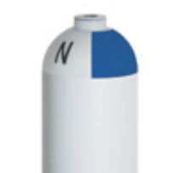 | Bubbling gaseous O2 in liquid nitrous oxide = gas behaves differently: Poynting effect  Pseudocritical temp -6oC, cylinder P=137 bar  If stored below pseudocritical temp will laminate leaving O2 above the layer of liquid nitrous oxide, O2 used first then -> delivery of hypoxic gas  Pipeline Entonox = 4 bar, pseudocritical temp of -30oC
Heliox® 79% He, 21% O2  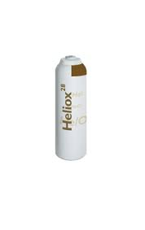 | Helium inert gas with lower density and specific gravity than room air (1.42 g/L vs 0.17g/L). Reduction in Reynold’s number, more laminar flow. Cylinder at 137 bar  Comes in ED size integral cylinder also with white and brown shoulders  Can also come as 100% Helium in Brown cylinders  Expensive 10x cost of oxygen  Can achieve FiO2 >0.4  Ventilators require recalibration for FiO2 and TV if run through ventilator
O2  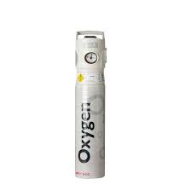 | Critical temp -118.2, critical pressure 50.4 bar  Stored in integral cylinders CD in Aus 630L at  BOC = “INHALO” trademark valve. However other companies with integrated valves exist
Air  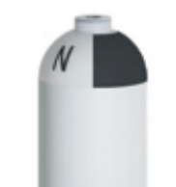 | More viscous than oxygen
CO2
