|  | | **Natural opium alkaloids** | | **Semi-synthetic** | | | **Synthetic** | | | | | **Synthetic** | **Synthetic** | | **Antagonist** |
| --- | --- | --- | --- | --- | --- | --- | --- | --- | --- | --- | --- | --- | --- | --- | --- |
| Benzylisoquinolines (Papaverine)  Phenanthrenes (morphine & codeine) | | Simple modifications of poppy alkaloid thebaine  Thebaine derivatives | | | Entirely synthesised in lab – not derived from poppy, less rings in their structures  Phenylpiperadines or anilidopiperadines | | | | | Diphenylpropylamine derivative, or phenylheptylamine | Synthetic phenylpropylamine | | Thebaine derivative |
| **Morphine** | **Codeine** | **Hydromorphone** | **Oxycodone** | **Buprenorphine** | **Meperidine Pethidine** | **Fentanyl** | **Sufentanil** | **Alfentanil** | **Remifentanil** | **Methadone** | **Tramadol** | **Tapentadol** | **Naloxone** |
| PC | Structure |  |  |  |  |  |  |  |  |  |  |  |  |  |  |
|  | Structure activity relationships | Template / proto-typical opiate | Substitution of methyl group for hydroxyl group on carbon 3 | Carbonyl group instead of hydroxyl on carbons 6 (therefore no active metabolite produced), and lacks double bond between carbons 7 & 8 | Similar to codeine – but has hydroxyl group at carbon-14  7-8 dihydro (rather than double bond)  Carbonyl group (instead of hydroxyl group of codeine) |  | Similar to LAs, tertiary amine, ester and phenyl group  Similar structurally to atropine! | Contain the phenanthrene nucleus of morphine but are manufactured not modified from morphine | No chiral centre | No chiral centre | Ester linkage for esterases to metabolise | Racemic, structurally unrelated to morphine  L-methadone = opioid agonist  D-methadone = NMDA antagonist (attenuate tolerance/ withdrawal) | Pro-drug  Racemic;  R(+) tramadol = 4 times more potent MOP R and 5HT reuptake  S(-) tramadol = NA reuptake | Non-racemic, has two chiral centres and exists as 4 enantiomers. But we use the single (R,R) stereoisomer | Pure competitive antagonist  Bulky substitution on the nitrogen atom (amine group) of morphine = antagonist |
|  | Agonism / Receptor Preference |  | Very weak mu-receptor agonist, relies on metabolism of 10% of dose to morphine |  | Metabolite of oxycodone (oxymorphone 19%) is 14 times more potent MOP agonist. Noroxycodone, major metabolite is only weak MOP agonist | Partial MOP agonist in-vitro (high affinity, dissociates slowly)  In vivo in clinically relevant doses behaves like full MOP agonist, analgesia to 10 hrs  KOP antagonist (anti-hyperalgesic effect) | Agonist at μ- and κ-opioid receptors |  |  |  | Potent MOP agonist | Full agonist  Potent μ-opioid, κ- & δ-opioid R agonist  Inhibitory effect on NMDA receptors  Inhibits 5HT3 & NA reuptake  Sodium channels | Agonist at μ R & weak κ- and δ-opioid receptor affinity.  Inhibits NA and 5HT reuptake & stimulates pre-synaptic 5-HT release | Weak opioid R agonist  Blocks reuptake of NA in brain  20x less affinity to MOP than morphine | Highest affinity for MOP receptors |
|  | Key notes / points of difference / formulations | Histamine release with large IV doses  Oral morphine = M6G may be primary active compound, due to hepatic first-pass effect. 85% of effect ater parenteral and 95% of effect after oral)  Low lipid solubility, crosses BBB slowly  M3G – no analgesic activity | **Pro-drug**, needs metabolism by CYP2D6, o-demethylation  Genetic polymorphisms  Asians have less CYP2D6  Ethiopians – ultrarapid  3-5% ultrarapid – higher levels  IV avoided – histamine release = hypotension | Higher lipid solubility than morphine = better BBB penetration, more rapid onset of action. Slightly better clinical analgesia than morphine with similar adverse effects  5 times as potent as morphine  H3G is dependent on kidney for excretion, has no analgesic action and can lead to dose-dependent neurotoxic effects | Available as immediate release and controlled release (Oxycontin) and controlled release with naloxone (Targin)  Resp depression worse than equivalent dose of morphine  High abuse potential | Ceiling effect of respiratory depression at 0.15-1.2mg in adults  Undergoes extensive 1st pass metabolism  Biphasic PK  50x affinity for μ receptors than morphine  Resp depression can be reversed with naloxone but higher than usual doses and infusion are required  Can prolong QT | 1939 – prototype for synthetics  Anti-shivering  LA activity  Atropine like antichol effects (↑ HR, dry mouth, less miosis)  30 times more lipid soluble than morphine, but 10 times less potent  Interacts MAOI  Only opiate be used as sole surgical block IT  More N&V  Naloxone does not reverse and may increase problems related to norpethidine toxicity | Lots of routes of administration: Oral transmucosal  Transdermal  Transnasal  Transpulmonary  Intrathecal  Causes facial itching, but no significant histamine release  Rapid onset is due to high lipophilicity, transfer half-life of 4.7-6.6 mins from plasma to CNS | Highest affinity for the μ receptors  5-10x potent than fentanyl  Highest lipid solubility of all commonly used opioids  Smaller Vd than fentanyl | Short acting after a bolus due to high diffusible fraction  Does have interindividual variability due to CYP3A4 variability and low HER compared to fentanyl  PB higher than fent, but due to low pKA – more unionised to diffuse | Structurally unique because of ester linkages  Hyperalgesia post cessation  Chest wall rigidity  Crystalline white powder – containing glycine  No histamine release  Not for intrathecal use – formulated with glycine  Administered as infusion 1mcg/kg/min | Longest half-life amongst the clinically used opioids  Highly variable interindividual. Withdrawal can take 6-7 weeks  Prolonged QT by blocking delayed rectifier K channel = mortality. Also torsades, pathological U waves, takutsubo, brugada-like syndrome  ANZCA position paper than should be avoided in acute pain/peri-op use | Active metabolite 30% of analgesia effect), 70% SSRI/SNRI properties  Marked decrease in post-op shivering  Interacts with warfarin  Avoid in epilepsy  Interacts with MAOIs  TCA  SSRI  5HT3 antagonists  Oral and IV formulations exist | Improved SE profile compared with other opioid agonists at equianalgesic doses  Potency between oral morphine and tramadol  Interacts MAOIs  Lowest rate of overdose deaths corrected for amount dispensed, lower rates of abuse and diversion than oxycodone  Oral only | DOA 30 minutes, therefore may require infusion  Reverses all opioid induced effects dose-dependent  High doses = HTN, tachycardia, arrythmias, APO, drowsiness  Formulated as hydrochloride, prepared pH 3.5  IV, IM or SC |
|  | Properties  Overall in Common | Opioids are Weak bases  Opioid receptors bind the protonated form = intensity related to the ionised concentration  Unionised, unbound fraction constitutes diffusible fraction = for speed of onset  Variable protein binding across the clinically used opioids – morphine (lowest at 35%, alfent, sufent and methadone = 90% PB)  Mostly follow a 3 compartmental model | | | | | | | | | | | | |  |
|  | MOA | All opioid receptors are linked through Gi/Go proteins and thus open potassium channels (causing hyperpolarisation) and inhibit the opening of calcium channels (inhibiting transmitter release) = decreased neuronal excitability  Inhibit adenylate cyclase and activate MAP kinase pathway)  MOP (mu) = most of analgesic effect + resp depression, constipation, euphoria, sedation and dependence  DOP (delta) = analgesia and pro-convulsant  KOP (kappa) = spinal level analgesia, sedation, dysphoria and hallucinations  NOP (nociceptin) = antiopioid effect, hyperalgesia at low doses, spinal analgesia, immobility and impairment of learning | | | | | | | | | | | | |  |
| PK | Relative potency | 1 | 10 times less potent than morphine | 5x morphine when PO  8x morphine when IV | 1.5x | 25x more potent | 0.1 | 80 – 100 x | 500 -1000x | 10 – 20x | Similar potency to fentanyl | 1 | 10 times less potent than morphine | 3 times less potent than morphine |  |
|  | pKa | 8 |  |  | 8.5 |  | 8.5 | 8.4 | 8 | 6.5 | 7.1 | 9.2 |  |  |  |
|  | % unionised @ pH 7.4 | 23% |  |  | <10% |  |  | <10 | 20 | 90 – responsible for speed of onset | 67 | 99% |  |  |  |
|  | Lipid solubility | 1.4 |  |  |  |  | 30 | 813 | 1778 | 145 | 17.9 |  |  | 1 |  |
|  | PB % | 20-40 |  |  |  |  | 70% | 84 | 93 | 92 | 80 | 90% |  |  |  |
|  | Primary protein | Albumin |  |  |  |  | Alpha-1-acid glycoprotein |  |  |  | Alpha-1-acid glycoprotein | Alpha-1-acid glycoprotein |  |  |  |
|  | Oral bio-avail | 25% | 60-70% | Similar to morphine – low | 60-90% | Low due to significant 1st pass metabolism | 80% | 30% |  |  |  | 80% (but can vary 35-100% | 75% |  | Very low (1st pass metabolism) |
|  | Onset (OOA)  Peak effect (PE) | OOA <1min (IV)  PE 5-20 mins (IV) | OOA 10-15 mins (PO) |  | OOA 10-15mins (PO) | SL tabs take 40mins – 3.5 hrs | OOA <1 min (IV)  PE 5-20mins (IV) | OOA <30 sec (IV)  PE 3-5 (IV) |  | OOA <30s (IV)  PE 1-2 mins (IV) |  | Peak plasma conc = oral 2-4 hrs  Epidural 15-20 mins  IT 30 mins |  | OOA 32 mins (PO)  DOA 4-6 hrs (PO) |  |
|  | 1st pass in lungs | Little |  |  |  |  | 65% | **Significant** | Similar to fentanyl |  |  |  |  |  |  |
|  | t1/2 a (min) | 1 – 2.5 |  |  |  | 2-3 |  | 1 -2 | 1 -2 | 1 – 3 | 0.5 – 1.5 |  |  |  | 2 |
|  | t1/2 B (min) | 10-20 |  |  |  | **40 HOURS** | 120 | 10-30 ?190 mins | 15-20 | 4-17 | 5-8 | **15- 60 HOURS** | 300 | 240 (4hrs) | 30-90 |
|  | t1/2 Y (hrs) | 2-4 |  |  |  | 24 |  | 2-4 (3-6 hrs) | 2-3 | 1-2 | 10 mins |  |  | 4.4-5.9 hrs |  |
|  | Vdc | 0.1-0.4 |  |  |  |  |  | 0.4-1.0 | 0.2 | 0.1-0.3 | 0.06-0.08 |  |  |  |  |
|  | VdSS (l/kg) | 3-5 |  |  |  |  |  | 3-5 | 2.5-3 | 0.4-1.0 | 0.2-0.3 | 4 |  |  |  |
|  | Metabolism  (major in bold, minor not bold) | **Glucoronidation (Phase II)**  **UGT**  demethylation | CYP2D6  **CYP3A4**  **UGT** | **UGT** | CYP2D6  **CYP3A4** | CYP3A4  UGT | CYP3A4  **Esterases** | **CYP3A4** | **CYP3A4** | **CYP3A4** | **Non-specific plasma and tissue esterases** | **CYP2B6**  CYP2C19  CYP2D6  **CYP3A4** | **CYP2B6**  CYP2D6  **CYP3A4**  UGT | CYP2C19  **UGT**  Sulfotransferase | Hepatic |
|  | Active metabolites? | **Yes**  70% MG3 (inactive)  10% MG6 – 13 times more potent than morphine  5% normorphine | **Yes**  via **CYP 2D6**  **Norcodeine** (10-25%  **Morphine** (10% of dose)  Glucuronidation to codeine-6-glucoronide | **No**  Major metabolite hydromorphone-3-glucuronide is inactive | **Yes**  via **CYP2D6**  **Noroxycodone** (less potent)  **Oxymorphone** (14 times more potent) | Yes  **Norbuprenorphine** | Yes  **Normeperidine** (via CYP3A4) (analgesic, and if accumulates can cause seizures – particularly in renal failure) | No  Demethylation -> **Norfentanyl** (inactive), then hydroxylation | **Yes**  But mostly inactive  N-dealkylation – to inactive and O-demethylation to methylsufentanil |  | **No**  Hydrolysis of remi to Inactive carboxylic acid metabolite “GI-90291” | **No**  N-demethylation in liver to EDDP (inactive) and EMDP (also inactive)  CYP3A4 inducers and inhibitors – intraction | **Yes**  via **CYP2D6**  **O-des-methyltramadol (M1)** – 6 times more potent, higher affinity | **No** |  |
|  | HER | 0.6-0.8 |  |  |  |  |  | 0.8-1.0  PK affected by liver failure | 0.7-0.9 | 0.3-0.5 | NA |  |  |  |  |
|  | Cl (ml/kg/min) | 15 |  |  |  |  | 12 | 10-20 | 10-15 | 4-9 | 30-40  Several times greater than HBF |  |  |  |  |
|  | Excretion | Renal |  |  | 10% excreted unchanged in urine | Predominately in bile  Unchanged in faeces |  |  |  |  | Renal | Urine |  |  |  |
| PD | CNS | Analgesia, euphoria, anxiolysis, unconsciousness at high doses  Reduce MAC by 60-90% - but ceiling effect  Hallucination, neuroexcitatory changes (pethidine – tremor, twitch, seizures) on EEG  ↑ CBF (due to hypercapnia), ↓ CMRO2, ↑ ICP (due to inc CBF)  Pupil constriction (MOP and KOP – stimulation of oculomotor nucleus – aka Edinger-Westphal nucleus), unaffected by tolerance  Impair thermoregulation  Prurutis – via histamine release (but not pethidine or fentanyl), dose-dependent, not mediated by opioid receptors  Opioid induced hyperalgesia (via NO, PKC and NMDA receptor activation), reduced by ketamine, propofol, a2-adrenoceptor agonists and COX-2 inhibitors  Tolerance | | | | | | | | | | | | |  |
|  | CVS | ↓ SVR -> ↓ BP (via direct effect on vascular smooth muscle, central sympatholytic activity and histamine release), hypotension pronounce with morphine and pethidine  ↓ HR (via CNS) – notably fentanyl and alfentanil, action via medulla – inhibiting baroreceptor reflex  Fentanyl provides little or no change to myocardial contractility, pethidine at high doses proven to cause myocardial depression | | | | | | | | | | | | |  |
|  | Resp | Depression of upper airway reflexes, suppression of cough reflex  Opioid induced respiratory depression – decreased RR and tidal volume  ↓ sensitivity to ↑pCO2, inhibition of respiratory rhythm generation – via u receptors in pre-botzinger complex in VRC of medulla)  ↓ ventilatory response to hypoxia  Bronchospasm (histamine release)  Chest wall rigidity, notable during large bolus, particularly remifentanil | | | | | | | | | | | | |  |
|  | Endocrine | Hypogonadism in males using chronically | | | | | | | | | | | | |  |
|  | Renal | Urinary retention – spasm, central and peripheral mechanisms  ↑ ADH | | | | | | | | | | | | |  |
|  | GIT | N&V – simulate CTZ in area postrema of medulla  Dry mouth  Inhibited gastric emptying  Dec motility – via visceral smooth muscle, intramural nerve plexuses, increased transit time, ileus  Inc biliary duct pressure – worsen biliary colic, spasm of sphincter of Oddi | | | | | | | | | | | | |  |
|  | Other / idiosyncratic opioid things | Ocular – augment oculocardiac reflex  Immune suppression  Cancer – long term opioid usage prior to diagnosis associated with decreased survival of some cancers  Wound healing effect  Remifentanil-induced post-infusion hyperalgesia / allodynia  Pethidine causes hypertension when given with a MAOI | | | | | | | | | | | | |  |
|  | Intrathecal opioids | Lipid solubility (affects onset)  Receptor affinity (duration of action)  Site of action – MOP receptors in substantia gelatinosa (dorsal horn of spinal cord)  Effects – segmental analgesia – synergistic with LA, greater for dull pain mediated by C fibres – than sharp pain Adelta fibres)  Reactivation of herpes simplex (morphine) | | | | | | | | | | | | |  |
|  | Allergy | True allergy is rare | | | | | | | | | | | | |  |
|  | Failure states | Remi’s PK not appreciably influenced by renal or hepatic failure and not influenced by pseudocholinesterase deficiency  Morphine in renal failure = accumulation of morphine glucuronides, M6G – particularly in dialysis patients | | | | | | | | | | | | |  |
|  | Elderly | 50% reduction in remifentanil requirement | | | | | | | | | | | | |  |
|  | Neonates | Reduced rate of elimination of all opioids  Immature CYP450 system. Normalises in the first year of life  NAS (neonatal abstinence syndrome)  Neonates can take up to 6 days to clear pethidine – highly urine flow dependent, but pethidine was used primarily in obstetrics due to classically less respiratory depression in the neonate | | | | | | | | | | | | |  |
|  | Children | Infusion rate of remifentanil 2 fold higher required for children | | | | | | | | | | | | |  |
|  | Obesity | Clearance appear to be more closely related to lean body mass | | | | | | | | | | | | |  |
|  | Pregnancy & breastfeeding | NAS  Morphine PCA = insignificant conc in colostrum | Used in pregnancy  Contraindicated in breastfeeding |  |  |  | Crosses the placenta |  |  |  |  | Crosses placenta with conc in amniotic fluid similar to that of maternal plasma |  |  |  |

Majority of Table Values from Millers, Stoelting & Hemmings & Egan, Rang and Dale and random statements from APMSE

<https://www.bjanaesthesia.org.uk/article/S0007-0912(19)30632-4/pdf>

Some of the morphine derivatives have chiral centres, but only the levorotatory enantiomer is significantly active at the opioid receptor

Interesting tid-bits about other non-clinically used opioids;

1. Pentazocine (benzomorphan class) has some antagonist properties and can antagonise the analgesia of the agonist drugs, increasing pain when given after morphine or pethidine. So it is the true example of an agonist-antagonist
   * Pentazocine also tends to cause dysphoria
2. Lofentanyl
   * Relative potency to morphine is 6000 !
   * Primarily in the research lab
3. Dextropropoxyphene
   * Low efficacy
   * Risks related to use include QTc prolongation, torsades and cardiogenic death
   * Withdrawn from TGA approval in Aus
4. Diamorphine = Heroin
   * Rapidly hydrolysed to monoacetylmorphine (MAM) and morphine.

Key Concepts / Diagrams

* 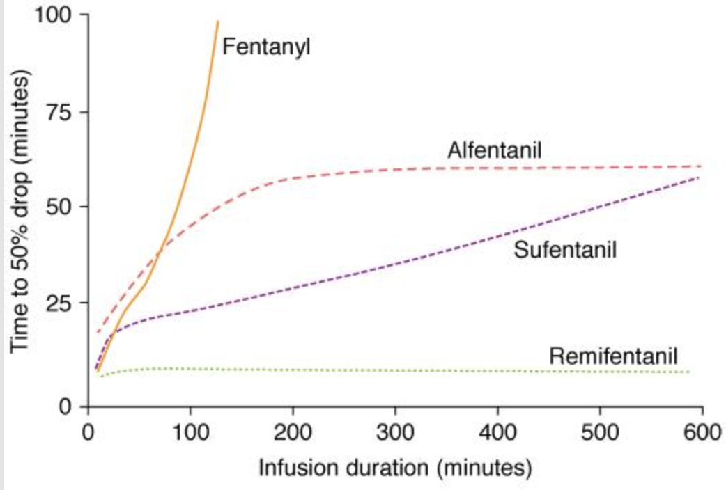

^this is missing MAPK and phospholipase (not sure if that’s cause its more recent?)