 | Trade Names | Actrapid®  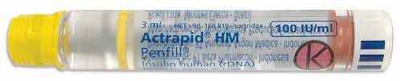  Humulin R ®  Hypurin® Neutral | Humalog®  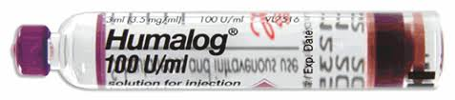 | Novorapid®  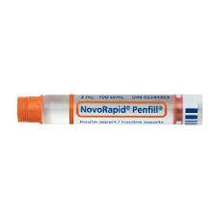  Novolog® (US)  FiAsp® (faster aspart) – ultrarapid  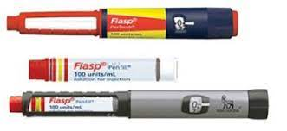 | Apidra®  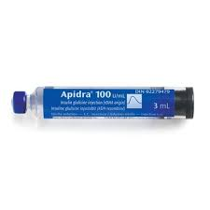 | Optisulin®  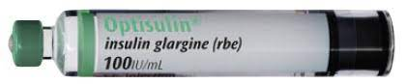  Semglee®  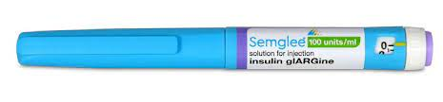  Toujeo®  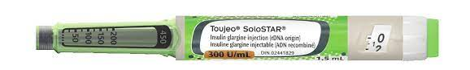  Lantus® - delisted from PBS | Levemir®  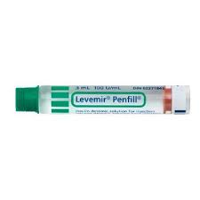 | Ryzodeg®  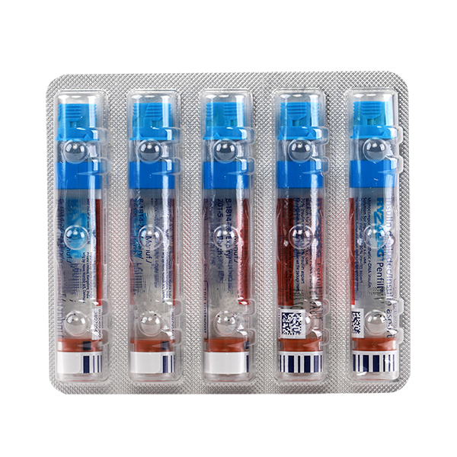 | Novomix®  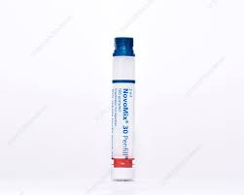 | Protaphane®  Humulin NPH®  Hypurin NPH® | Mixtard® 30/70  Mixtard® 50/50 | Humalog® Mix 25  Humalog® Mix 50
PC | Generic names | Neutral insulin  Human insulin | Insulin lispro | Insulin aspart | Insulin glulisine | Insulin glargine | Insulin determir | Insulin degludec 70% + insulin aspart 30% | Insulin aspart 30%  Insulin aspart protamine 70% | Isophane insulin  NPH insulin | Insulin neutral (rys)  Insulin isophane (rys) | Insulin lispro  Insulin lispro protamine
 | Type | Short-acting human insulin | Rapid-acting analogue | Rapid (or ultra-rapid) acting analogue | Rapid acting analogue | Long acting analogue | Long acting analogue | Mixed analogue – ultra-long acting degludec and rapid acting aspart | Biphasic, mixed aspart analogue and protamine suspension of aspart | Intermediate acting protamine  suspension of neutral insulin | Biphasic mixed insulin, of neutral and suspension of neural insulin | Biphasic mixed insulin of analogue and protamine suspension of analogue
 | Structure | 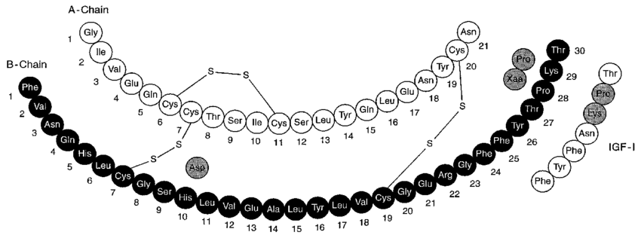 | 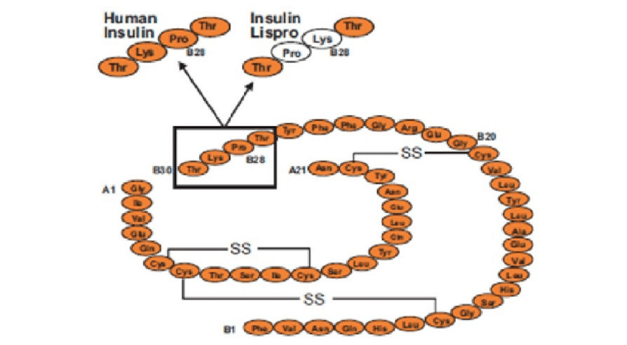 | 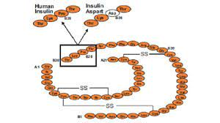 | 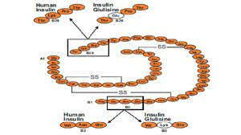 | 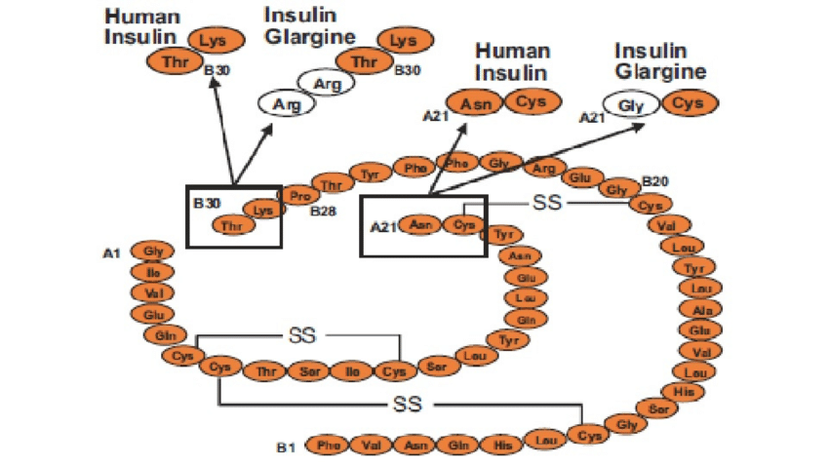 | 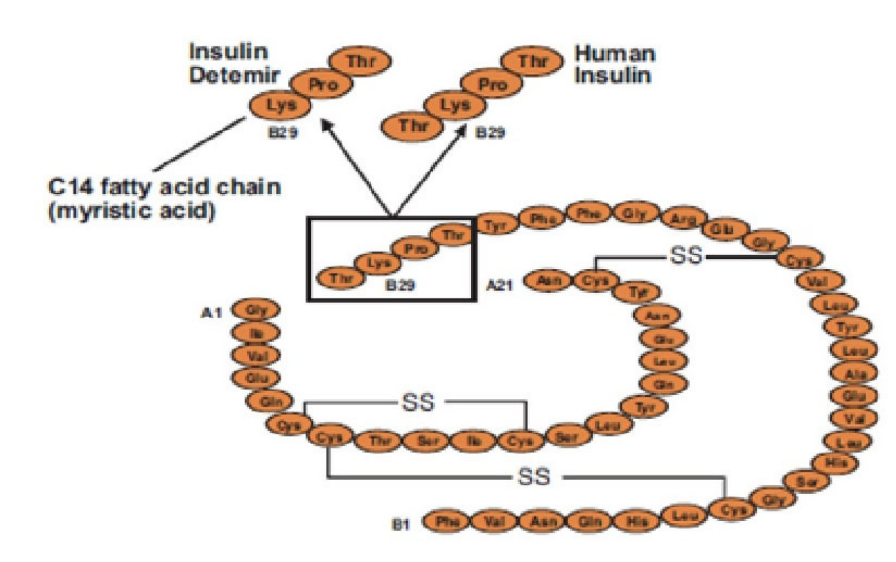 | 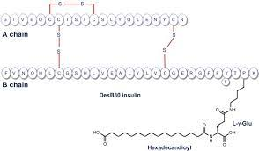 | 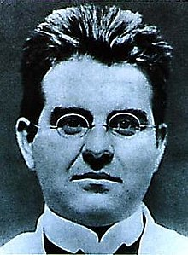
 | Structural notes | Structurally identical to natural human insulin  Produced via recombinant DNA technology (rys) using e-coli or bovine extraction (rbe) – Hypurin R | Insulin lispro (rbe)  The normal sequence of proline at position 28 of the B chain and lysine at position 29 are reversed – causing faster absorption, higher peak and shorter DOA – with same receptor affinity | Insulin aspart (rys)  Similar to human insulin except for B28 proline is substituted with an aspartic acid residue  Made from yeast – harvested from a bioreactor, rDNA using  Saccharomyces cerevisiae  Reduces the formulation of a hexamer – (stays as a monomer) makes it work faster – absorbed twice as fast as neutral insulin | Amino acid asparagine (B3) is replaced by lysine and the lysine position (B29) is replaced by glutamic acid | Recombinant analogue produced by rDNA technology using non-pathogenic strains of e-coli  2 arginine residues to C-terminus of insulin B chain and replacement of a single asparagine residue with a glycine in the A chain.  ***The unique pH stabilises the hexamer – but prevents mixing with short acting neutral pH solutions. It micro-precipitates in the neutral pH of s/c tissue – slowing absorption | Deletion of threonine - B30 and a myristic acid (C14 fatty acid chain) bound to the lysine at position B29  Molecules bind together more avidly, slowing absorption into circulation | Insulin degludec (rys)  Insulin aspart (rys)  Formulated by deleting the last amino acid (thronine B30) of the B chain of human insulin and adding a glutamyl linkage to a hexadecedioic fatty acid (C16 fatty acid).  Soluble stable multi-hexamers result in a depot from which insulin degludec monomers are slowly and continuously separate and absorbed into circulation | Insulin aspart (rys) plus protaminated aspartate | Protaphane (rys)  Humulin NPH Isophane (rbe)  Hypurin® - Isophane NPH bovine
 | pH | 7-7.8 | 7- 7.8 | 7.2 – 7.6 | 7.3 | 4 | 7.4 | 7.4 |  |  |  | 7 – 7.8
 | Protein binding |  |  | <10% protein binding |  |  | 97% protein bound | degludec >99% plasma protein binding to albumin  aspart <10% plasma protein binding
 | Presentation | Clear colourless solution  10 ml vial 100units/ml | 3ml cartridges and pens  10ml vials 100 units/ml | Clear colourless solution  3ml cartridge containing 100 units/ml | Clear colourless solution  3ml cartridges of 100 units/ml and 10 ml vials | Clear colourless solution  3ml cartridge 100 units/ml  Toujeo® Solostar 300 units/ml 1.5ml or 3ml Doublestar which is 2 to 160 units in one injection, also SoloSTARMax 300units/ml – 3mls  Also 10ml vial | Clear colourless solution, Flexpen 3ml cartridge or Penfill 3ml | Clear colourless solution  3ml cartridge  Flextouch pen 1-80 units increments of 1 unit | Sterile cloudy white aqueous suspension  3 ml cartridge of 100 units/ml | Sterile cloudy white aqueous suspension  10ml multidose vial | Sterile cloudy white suspension  100 units/ml  Not equivalent to separate parts | White suspension  100units/ml in a 3ml cartridge and 3ml pre-filled pens KwikPen
 | Shelf life | 30 months when stored between 2- 8 degrees. Cannot be frozen – discard if frozen. Needs protection from light. When in pen/in-use – room temperature (below 25 degrees) for up to 4 weeks. Cartridges of suspension contain a glass ball to facilitate resuspension
 | Excipients | Glycerol (tonicity)  Phenol (preservative)  Metacresol (preservative)  Zinc chloride  Sodium chloride  Dibasic sodium phosphate dihydrase (buffer)  Sodium hydroxide  HCl  Water for injection | Metacresol  Glycerol  Dibasic sodium phosphate hepatahydrate  Zinc oxide  Water for injection  HCL  Sodium hydroxide | FiAsp has nicotinamide (B3) – which reduces the tendency of insulin molecules to self-associate – leading to faster dissociation of hexamers into dimers and monomers – into circulation.  Glycerol, phenol, metacresol, zinc chloride, dibasic sodium phosphate dihydrate, sodium chloride, sodium hydroxide, hydrochloric acid and water for injections | Metacresol, trometamol, sodium chloride, polysorbate 20 (vials), hydrochloric acid and sodium hydroxide (pH) and water for injections | 10ml vial also contains polysorbate 20  Glycerol  Hydrochloric acid  Metacresol  Sodium hydroxide  Zinc chloride (precipitant)  Water for injection | Glycerol  Phenol  Metacresol  Zinc acetate  Dibasic sodium phosphate dihydrate  Sodium chloride  Hydrochloric acid  Sodium hydroxide  Water for injection | Glycerol  Metacresol  Phenol  Sodium chloride  Zinc acetate  Hydrochloric acid  Sodium hydroxide  Water for infection | Protamine sulfate (a fish product), glycerol, phenol, metacresol, zinc chloride, dibasic sodium phosphate dihydrate, sodium chloride, sodium hydroxide, hydrochloric acid and water for injections. | hydrochloric acid or phosphoric acid or sodium hydroxide  protamine sulphate  zinc chloride  sodium phosphate  metacresol  phenol  glycerol  water for injections | Glycerol, metacresol, phenol, dibasic sodium phosphate dihydrate, zinc chloride, protamine sulfate, water for injections. Hydrochloric acid & sodium hydroxide | Metacresol, phenol, glycerol, dibasic sodium phosphate heptahydrate, protamine sulfate, zinc oxide and water for injection. Hydrochloric acid and sodium hydroxide
 | Uses / points of difference | Insulin infusions in hospital  If used s/c as a bolus with meals, needs to be given 30 mins prior to the meal  Don’t use for cont s/c infusion as precipitates in pump catheters | Immediately prior to meals  Can be used in a continuous subcutaneous insulin infusion pump | Bolus with meals in a basal bolus regime – superior to Actrapid for this  Can be used IV  FiAsp can be used in continuous s/c infusion pump (for 6 days) | Not compatible with 5% dextrose | Long acting basal  Cannot be given IV | Can be used once daily – as DOA is up to 24hrs  Or twice daily – in which steady state conc are reached after 2-3 doses  Less variable than NPH or glargine | Once or twice daily with the main meals  Can be used in children from age 6  NOT For IV or IM administration  Steady state occurs after 3-4 days of dose administration | Must be given with a meal (due to aspart component) | Cannot be given IV  Once or twice daily  But can be mixed with actrapid | Once daily or BD  30 minutes prior to meals | Once daily dosing  Immediately with a meal
PK | Onset | 30-45 minutes | 15 minutes | 15 minutes  FiAsp – 5 minutes faster | 15 minutes | 1-2 hours | 3-4 hours | 14 minutes | 15-20 minutes | 1.5 hours | 30 minutes | 15-20 mins
 | Peak | 1.5 to 3.5 hrs | 1 hr | 72 minutes  FiAsp – 4 times as much insulin available in first 15 mins, twice as much available in first 30 minutes. Total insulin unchanged | 60 minutes | No peak | 6-8 hours | Aspart (72 minutes)  Degludec (9 hours) | 1 hr | 4-12 hours | 2-8 hrs (50/50)  2-12 hrs (30/70) | 1 hr
 | Approx DOA | 6-8 hours | 2-5 hours | 2-4 hours | 1.5 hours | 18-24 hours (24-36 for Toujeo) | 20-24 hours | >40 hours | 14-24 hrs | 24 hours | 24 hours | 14-24 hrs
 | Elimination half-life | 10 minutes |  | 57 minutes |  |  |  | Insulin degludec – half-life of basal component is approx 25 hours independent of dose
 | Modifiers of DOA | Dose  Injection site (IV > S/C injection into the abdominal wall > Upper arm and gluteal > thigh)  Blood flow to injection site  Temperature  Level of physical activity
 | Dose-time curves |  |  | 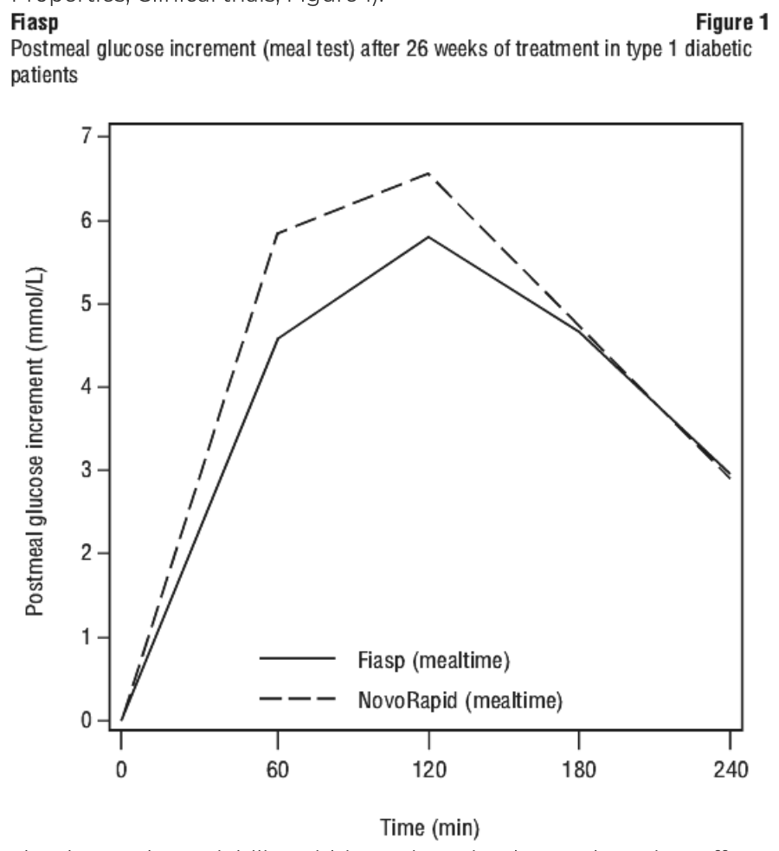 | 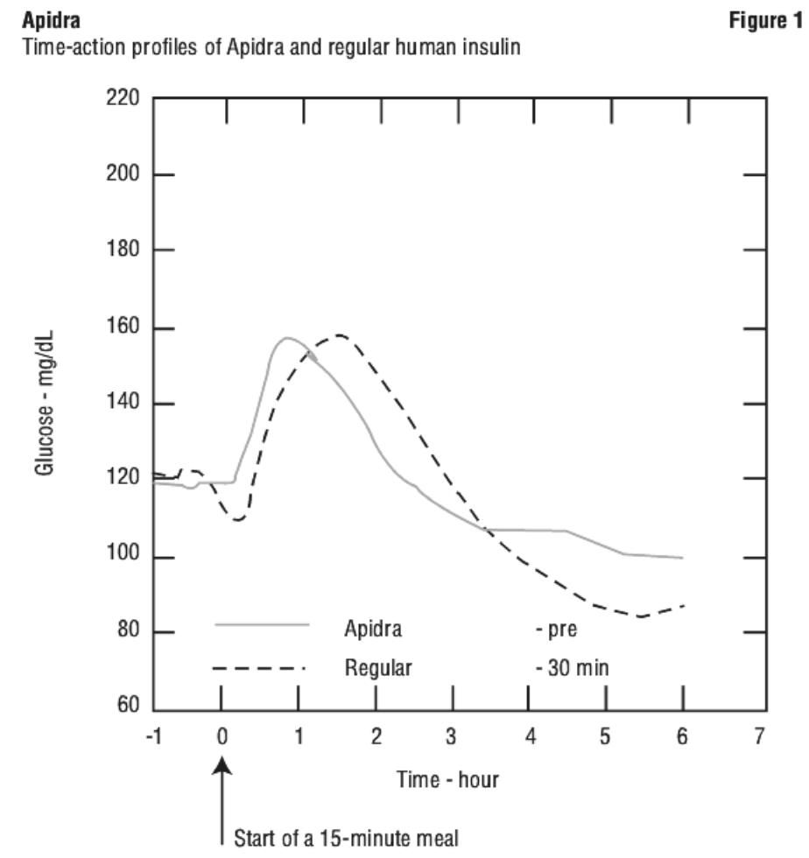 | 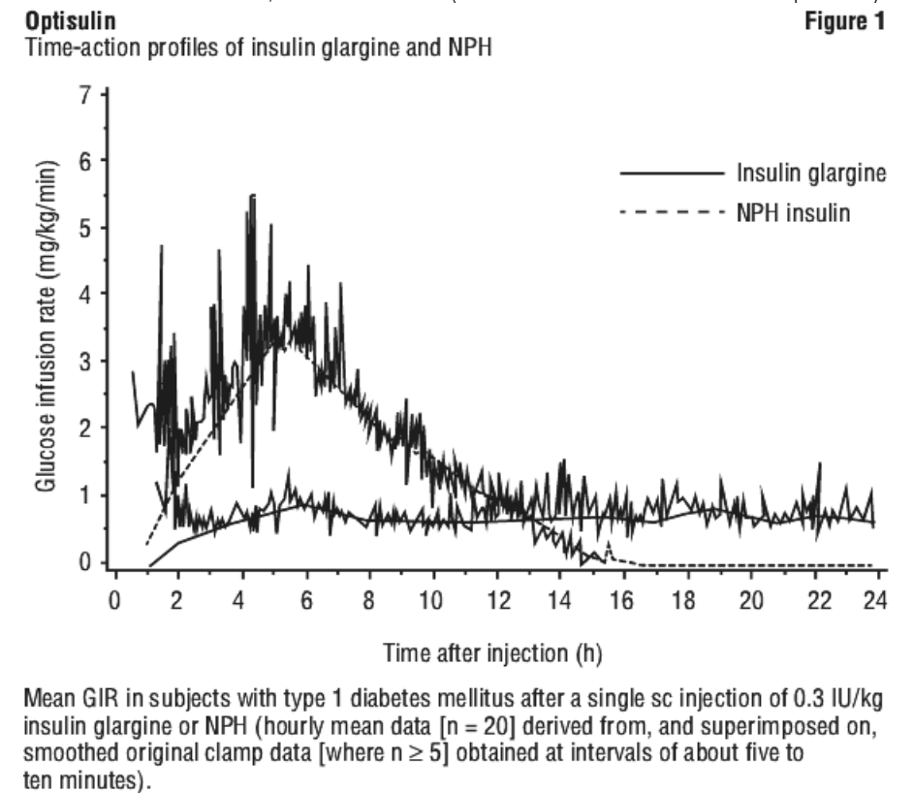 | 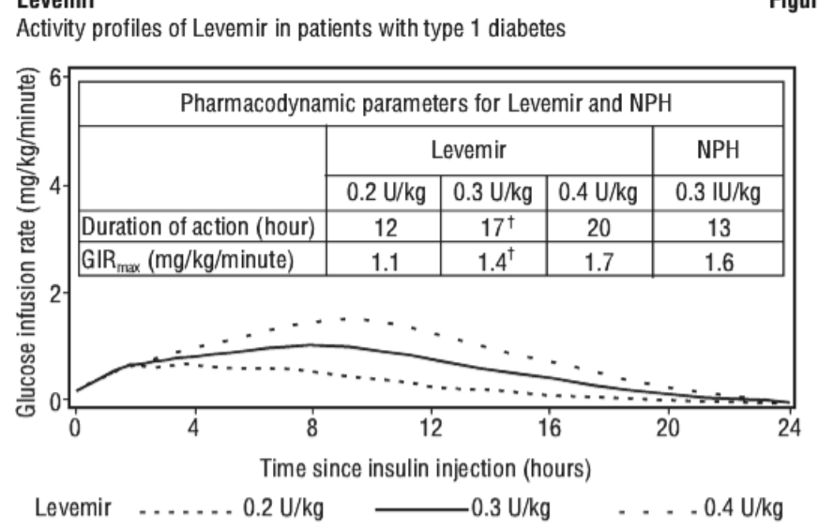 | 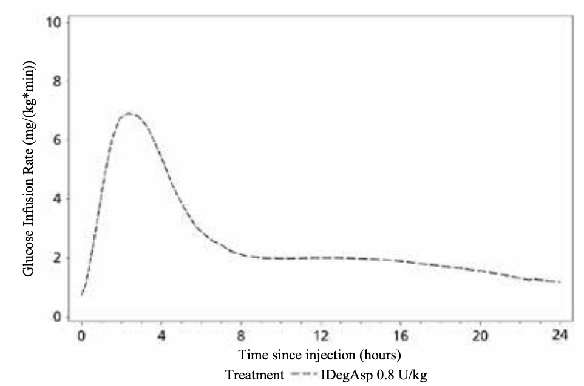
 | Receptor affinity |  |  |  |  | Insulin glargine has 5-8 fold greater affinity for IGF-1 receptor (but 70-80 fold lower still than IGF-1)
 | Metabolites | Inactivated enzymatically in the liver and kidney  10% excreted in urine |  |  |  | 2 active metabolites M1 and M2 |  | Inactive metabolites
PD | MOA | Binds to the insulin receptor (large transmembrane glycoprotein (TK type3) with 2a and 2B subunits. Insulin binds to the 2a subunits, increasing tyrosine kinase activity of the 2B subunits, causing autophosphorylation.  This stimulates peripheral glucose uptake by skeletal muscle and fat and inhibits hepatic glucose production  Insulin inhibits lipolysis in the adipocyte inhibiting proteolysis and enhancing protein synthesis.  Also long term entails effects on DNA and RNA by the Ras signalling complex, activation of MAP-kinase and transcription factors leading to gene expression of genes involved in cell growth and intermediary metabolism
 | CVS/Resp/  Neuro | Notable effects on serum potassium concentrations – can affect CVS system  Afrezza insulin inhaler – can be used as a substitute for bolus insulin with meals, limited dosing flexibility, currently available only in US  Hypoglycaemic neuro effects
 | Renal | Renal and hepatic disease may reduce the patient’s insulin requirements
 | GIT | The GI tract destroys insulin – therefore there are no oral preparations
 | Metabolic | Inc glucose uptake  Inc glycogen synthesis  Dec glycogenolysis  Dec gluconeogenesis  Inc transport of K and Ca2+ into cells
 | SE’s | Hypoglycaemia  Lipodystrophy / lipoatrophy / lipohypertrophy  Cutaneous amyloidosis  Weight gain (due to anabolic effects and decreased glycosuria)  Sodium retention  Oedema – usually on initiation of insulin therapy – usually transitory  Rapid intensification of insulin therapy can cause painful neuropathy (reversible) and temporary worsening of diabetic retinopathy  Insulin resistance – rare, or insulin antibodies  Hypersensitivty
 | Interactions | Thiazolidinediones (glitazones) + insulin s/c = congestive cardiac failure  Insulin absorbs into infusion bag. Mixed insulin infusions are stable at room temperature for 24 hours in polypropylene infusion bags  Substances that reduce insulin requirements: oral hypoglycaemic agents, octreotide, lanreotide, MAOIs, non-selective B-adrenergic blocking agents, ACE, salicylates, alcholol, anabolic steroids, a-adrenaergic blocking agents, sulphonamides, quinine  Substances that increase insulin requirements: OCPs, thiazides, frusemide, ethacrynic acid diuretics, glucocorticoids, thyroid hormones, GH etc etc  B-adrenergic blocking agents + hypoglycaemia can precipitate hypertensive crisis  Betablockers and clonidine can mask the adrenergic signs of hypoglycaemia  Insulins for IV injection are not compatible with rocuronium, glycopyrronium, piptaz, noradrenaline, phenylephrine, protamine
 | A note about NPH | Neutral Protamine Hagedorn Insulin (NPH) AKA isophane insulin  - Made by mixing regular insulin and protamine with zinc and phenol – so that a neutral pH is maintained and crystals form – hence cloudy  - Protamine (fish/ salmon sperm protein) added to regular human insulin to delay its absorption. Needs remixing, unpredictable absorption  - Intermediate DOA. Onset 1-4 hrs, peak 6-10 hours, DOA 10-16hrs  - Hans Christian Hagedorn (see pics above)
One IU (international unit) of insulin corresponds to a variable amount of pure crystalline anhydrous insulin (eg 0.035mg). It was initially recorded as the amount required to lower the fasting blood sugar by 2.5mmol/L

References
- Krishnappa mane et al. Journal of Basic and Clinical Pharmacology Vol-003, Issue-002 May 2012
- NPS MedicineWise, full PIs – online
- RACGP Clinical guidelines – online
- Increased risk of severe protamine reactions in NPH insulin-dependent diabetics undergoing cardiac catheterization https://pubmed.ncbi.nlm.nih.gov/6488493/ . 50-fold increase in risk of major reaction. One death ensued. Incidence of major protamine reactions 27%.
- Novonordisk – Australian product information for available insulins
- Rang and Dale’s Pharmacology

